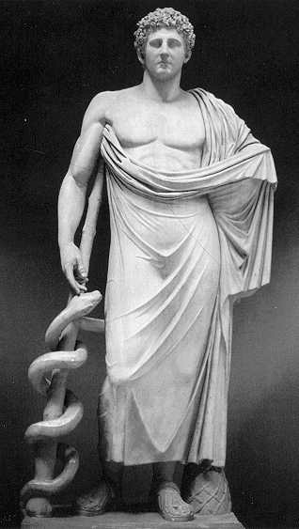
REQUEST FORM TO THE "ASKLEPIOS" PROGRAM
UNIVERSIDAD DE LA LAGUNA

PERSONAL DETAILS OF THE STUDENT:

SURNAME:

NAME:

ADDRESS: PASSPORT:

TELEPHONE: E-MAIL:

DATE AND SIGNATURE:

INSURANCE:

COVERINGS:

FULL NAME OF THE PARENTS/TUTOR:

ADDRESS: PASSPORT:

TELEPHONE: E-MAIL:

(FILL IN THE CASE BELLOW IN CASE OF NO TUITION)
DETAILS OF CONTACT PERSON IN CASE OF ANY EVENTUALITY:

SURNAME AND NAMES OF THE PARENTS or TUTOR:

ADDRESS: PASSPORT:

TELEPHONE: E-MAIL:
Send to:
UNIVERSIDAD DE LA LAGUNA
Prof. Dr. Olga Ferrer-Roca

CATEDRA DE ANATOMÍA PATALOGICA
UNESCO CHAIR TELEMEDICINE
FACULTAD DE MEDICINA
La Cuesta
38071 TENERIFE
Canarias- Spain

TELEPHONES: 922319321 - 922661600
FAX: 922641855
LEVEL OF SPANISH UNDERSTANDING:

SPOKEN: _NONE _LOW _MEDIUM _HIGH
WRITEN: _NONE _LOW _MEDIUM _HIGH

