SUPERCOMPUTING TELEMEDICINE PLATFORMS
ANASTASIA N. KASTANIA
Department of Informatics,
Athens University of Economics & Business, Greece
e-mail: ank@aueb.gr

The process of developing applications on a parallel computer consists of two main steps: allocation of the computation across the processors and implementation of the allocation decision. Supercomputers are coming into wider use for generating realistic medical imagery. The production of good quality images in real time requires specialized computer architectures exploiting parallelism (Figure 1).

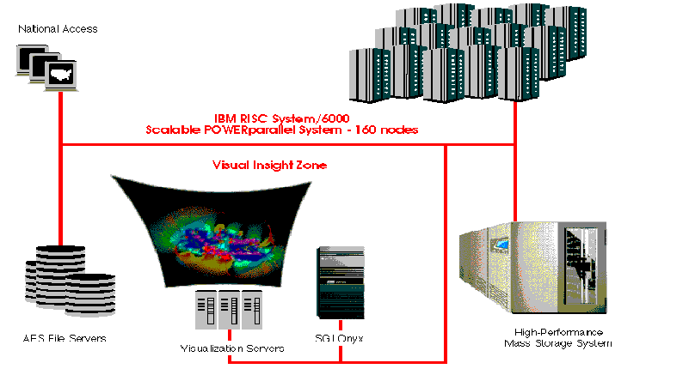
Figure 1: High performance computing

Computerized medical imaging devices such as Computed Tomography (CT), Magnetic Resonance (MR) and Positron Emission Tomography (PET) scanners have the ability to acquire vast quantities of data about the human body, usually in the form of cross-sectional images or 'slices' containing anatomical, physiological or biomedical information. A family of high performance graphics processors has been designed specifically for the above medical applications.
Voxel processor systems architectures[1] provide 3D representations on a 2D-video monitor using computer graphics techniques such as hidden surface removal, realistic shading and motion parallax to enhance the perception of depth. The Voxel processors may be thought of as an instrument for the exploration and analysis of medical imaging data and applications exist in general diagnosis, and surgical and radiation therapy and planning.
Image reconstruction in CT can be achieved using multiprocessor-based architectures [1] that map the filtered backprojection algorithms and consist of inexpensive modules designed with general-purpose LSI/VLSI chips connected in a 2D-grid topology.
Various parallel machines (Figure 2) supporting different computation models have been built; among them the Hypercube, the Transputer, the Connection Machine (Figure 3) and the Warp systolic array.
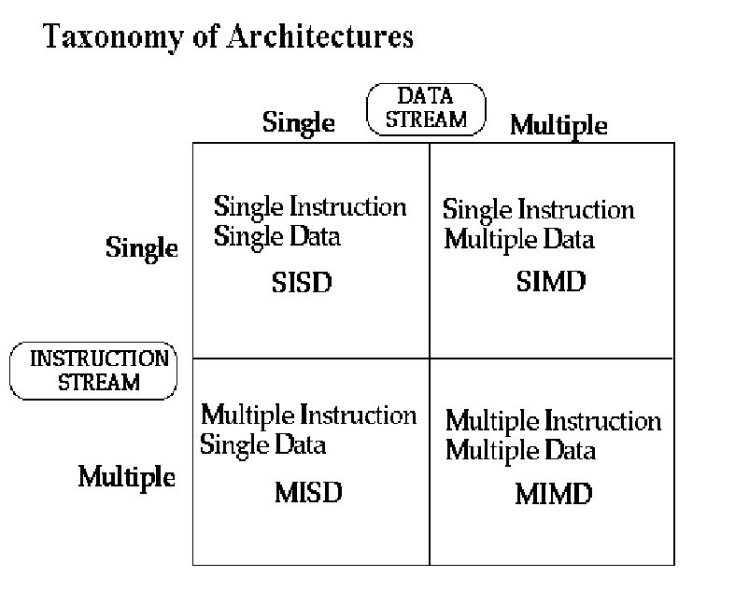
Figure 2: Taxonomy of architectures

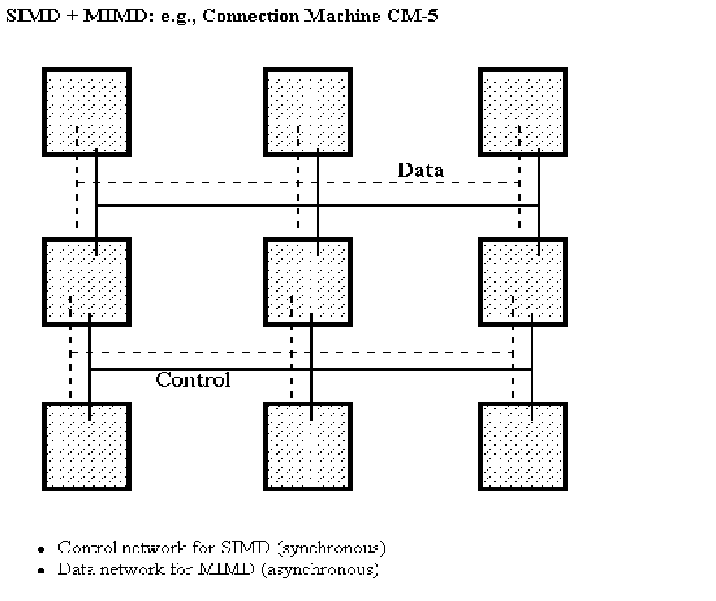
Figure 3: Connection Machine

Fine grain parallel computers can be used for the establishment of a Supercomputing Telemedicine platform. These consist of a large number of simple Processing Elements (PEs) connected by an Interconnection Network (IN) [2,3]. Due to the quantity of PEs, the model of computation is usually SIMD (Single Instruction Multiple Data) (Figure 4). A central controller broadcasts a stream of instructions to all the PEs to control both the PE operations and the interconnection network. Since each PE has to carry out a small fraction of the algorithm for medical image analysis and reconstruction, the overall performance can be great if communication among PEs does not degrade the computation. In fine grain parallel computers the interconnection network is usually directly connected [4] because the large number of PEs makes the indirect connection undesirable.
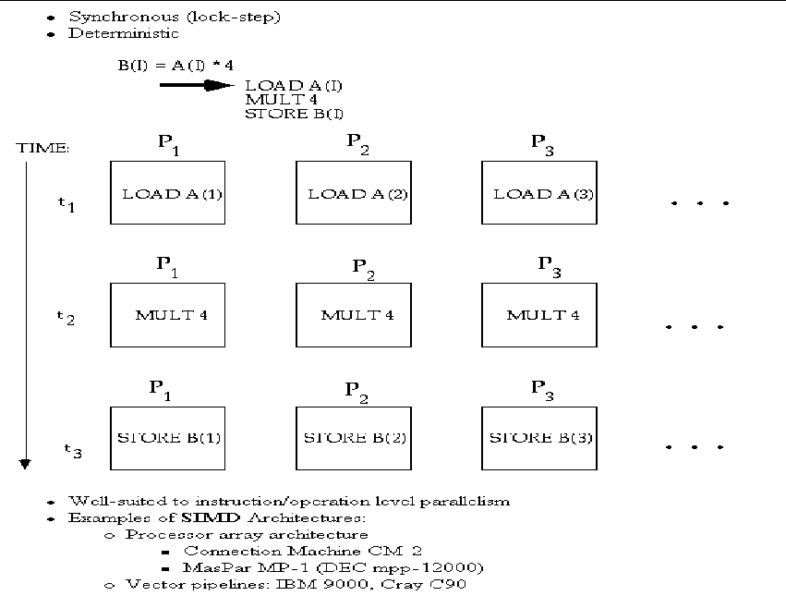
Figure 4: SIMD Architecture
Two issues are very important in IN design. The first issue is concerned with matching the application task graph to the network topology. For example mesh-connected computers are popular for image processing [5,6]. When the application environment is not known, topology with small diameter is favored. A modern and popular choice for this case is the hypercube topology. The second issue is the engineering of the network with connection autonomy [7], which demands the identical behavior of all processing elements via the broadcast instruction issued by a central controller.
References
1. | Parallel Processing for Computer Vision and Display (eds. Dew P.H., Earnshaw R.A. Heywood T.R.), Addison-Wesley Pubs, 1989.
2. | Enslow P.H. (1977). Multiprocessor organization-a survey. ACM Computing Surveys, 9(1), 103-29.
3. | Flynn, M.J. Very high speed computing systems, Proc. IEEE, 54(12), 1901-9.
4. | Uhr L. (1984). Algorithm Structured Computer Arrays and Networks. New York: Academic Press.
5. | Danielsson P.E. and Levialdi S. (1981). Computer architectures for pictorial information systems, IEEE Computer, 14(11), 53-67.
6. | Reeves A.P. (1984). Parallel computer architectures for image processing. Computer Vision Graphics and Image Processing, 25(1), 68-88.
7. | Maresca M. & Li H. Toward connection autonomy of fine-grain SIMD parallel architecture.Parallel Processing for Computer Vision and Display (eds. Dew P.H., Earnshaw R.A. Heywood T.R.), Addison-Wesley Pubs, 1989.

