TELEMEDICINE SERVICES IN GREEK ISLANDS
ANASTASIA N. KASTANIA
Department of Informatics,
Athens University of Economics & Business, Greece
PAaRG-BEaT R&D Centre
e-mail: ank@aueb.gr

The Greek Telemedicine programme started in 1989. The first pilot implementation had terminal connections among the Internal Medicine Department of Sismanogleion Hospital and the Primary Care Centres of Spata, Paros island, Hospital of Karpenision and the Primary Care Unit of West Fragista. This phase was funded by the Greek Ministry of Health, the General Secretary for Research and Technology and the NATO programme Science for Stability. In spring 1990 was signed with the Greek Telecommunications Provider (OTE) agreement for the installation of three more terminals in primary healthcare units and funding from the Greek Ministry of Health resulted to 13 installations in various places in Greece, 2 in Sismanogleion hospital and one in the Medical Physics Laboratory of the National Capodistrian University of Athens.
The stategic selection of the Greek Telemedicine Programme was to use the existing telephone network for image transmission among the primary healthcare units and the Sismanogleion Hospital for the improvement of health care services provision in the isolated primary health care units. The equipment that has already been used for the provision of Telemedicine Services in the Aegean Islands (Fig. 1) consists of a telephonic centre DEFINITY 75/85 from AT&T, connected to computer terminals with modems (19.2 Kbps), image digitizers and vidicon acquisition devices.

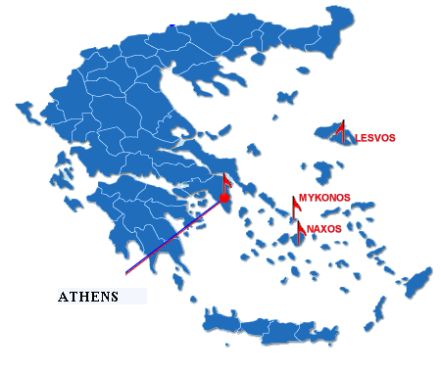 | The following  isolated  islands  are also  supported  via Telemedicine  Services since 1992:  - Limnos(Fig. 2)  - Ikaria  - Paros  - Skopelos  - Santorini  - Astypalaia  - Fournoi  - Kastelorizo
Fig 1: Map of Greece and main Telemedicine Units in Greek Islands

In April 1992 when the connection of the Primary Care Units was completed in the initial form of the Greek Telemedicine Network, 3000 cases had been served (pneymonological:27%, cardiological: 17%, orthopaidics:21%, Ourology:5%, Surgery: 2%, Supporting and Diet: 12%).
That year was also established the service of regular teleconsultation for medical diagnosis provision in the Greek Islands via the Sismanogleion Hospital Telemedicine Unit.
Infrastructure and Equipment  Medical Equipment  - X-Rays laboratory, performing simple x-rays  - Digital and non-digital ECG machines. The former can be attached to a computer, and is accompanied by ECG processing and interpretation software  - Blood Analyzer  - 3 biochemical analyzers  - Dental Equipment  - 2 microscopes  - Defibirllator  - 24 hour blood pressure monitoring  - Simple Doppler  - Cardiotocographer  Computer Infrastructure  - Network consisting of 5 Pentium computers, of various specifications  - 8-bit film digitizer (Vidar scanner)  - Backup units (magneto-optical disks)  - Satellite Communication StationTDM/TDMA 64 kbps (Very Small Aperture antenna Terminal)  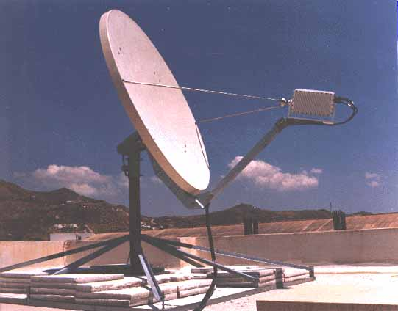  - 28.8 Kbps Modems, used to communicate ECGs between the Health Care Center and tertiary Hospitals of the Athens area, via PSTN  - Electronic Healthcare Record Software (HEALTH.one)  Other Infrastrucure  - Two ambulances | 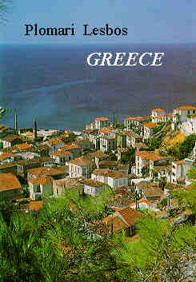  The Health Care Center of Plomari:  All information concerning each patient are recorded in Electronic Format, using computers, and are communicated to the hospitals via several types of communication media. The speciailized physician(s) study the case and, in cooperation with their local colleague(s), decide on the indicated treatment.  The type of the information exchanged differs between the various EU projects the Health Care Centre participates .  - In the context of the TALOS Project only the ECG of the patient is transmitted.  - In the context of the HERMES Project the complete Electronic Healhcare Record of the patient is transmitted. The latter contains the history, physical examination, ECG, X-rays and laboratory investigations, that may have been performed.  Data are transferred via simple PSTN lines, in the context of the TALOS Project. In the cotnext of the HERMES they are transferred via satellite links.
Fig. 2: Healthcare Center Infrastructure & Telemedicine Services: Plomari, Lesvos Island, Greece
(http://www.mednet.gr/greek/depts/plomari/)
The design of Telecardiology Services TALOS was based on the results of the European Programme FEST (Framework for European Services in Telemedicine) funded by the European Comission in 1992-1994. Each one of the 7 participating primary care units (in the Islands: Mykonos, Skiathos, Santorini, Naxos, Milos, Lesvos, Amorgos) had a digital cardiographer and a computer and ECG transmittion to the Onasseion Cardiac Centre in Athens was sucessfully implemented through the regular telephone network. Transmission is also feasible through GSM.
HERMES (Telematic Healthcare Remoteness And Mobility Factors In Common European Scenarios), a 4th Framework Programme Project of the Commission of the European Union, designed a platform for the development of quality assured Telemedicine Services at the point of need. In the context of the platform’s evaluation, the HERMES Greek partners have implemented Maternity Telemedicine Services between the Primary Healthcare Centres of the Islands of Naxos and Mykonos, in the region of the Aegean Sea, and the Aretaieion University Hospital in Athens, Greece. The services are offered by expert gynaecologists / obstetricians to primary care physicians and/or midwives, confronted with emergency or difficult to interpret maternity cases. Patient related information is recorded with the aid of patient record software, and may include (textual) gynaecological information and Cardiotocograms (CTGs). The records are transmitted to experts via ISDN links, while discussion on the case can be performed via video-conferencing. During the initial implementation phase, the maternity services have been offered to 40 individuals. The services are found to be a significant aid for Primary Care Units that do not have access to obstetric expertise.
The Greek Ministry of Health, in 1998, funded a study on the development of Telemedicine Information Systems and in 1999, moved towards the design and implementation of an integrated National Telemedice Action Plan. This is currently under progressive development.

References
A.N. Kastania, Telemedicine Systems & Services:the Greek Case, Healthcare Information Technology Journal, June 2000.
M. Gatzonis , S. Deftereos, MD , P. Vasiliou, MD , F. Dimitriou, Midwife , G. Creatsas, Prof., MD, D. Sotiriou, Assoc. Prof., K. Boddy, Senior Lecturer, MD, Maternity Telemedicine Services in the Aegean Islands, June 2000 (http://alpha.mpl.uoa.gr)

