Virtual Reality applied to Liver Surgery

L. Soler (1), J. Marescaux (1), D. Mutter (1), C. Koehl (1),
H. Delingette (2), G. Malandain (2), N. Ayache (2),

- IRCAD Strasbourg, France, (2) INRIA Sophia Antipolis France

KEYWORDS: Virtual Reality, Anatomical Segmentation, Surgical Planning, Hepatic surgery

Purpose: In order to help hepatic surgical planning, we have developed several algorithms for the automatic 3D delineation of anatomical and pathological hepatic structures from a spiral CT-scan. We also extract functional information useful for surgery planning, such as portal vein labelling and anatomical segment delineation following the conventional anatomical definitions separating the liver in several functionally independent anatomical segments.
Methods : From a 2mm thick spiral CT-scan acquired after contrast agent injection between portal venous phase and hepatic venous phase, a first computational stage extracts 3D-models of the skin, bones, lungs, and kidneys, combining the use of thresholding, mathematical morphological methods and distance maps. All parameters used in this first stage are fixed based on expert anatomical knowledge (as, for instance, the localization of bones and kidneys from the skin) or are computed from a grey-level histogram. Next, a 3D reference model of the liver is embedded in the CT-scan and, by applying local and global constraints, deformed automatically towards patient liver contours. The CT-scan image is then cropped to the liver contours and filtered by anisotropic diffusion¹, in order to improve contrast without blurring the vessel and lesion outlines. A least-square fitting of three Gaussian distributions onto the grey-level histogram is used to estimate several thresholds allowing for a first classification of voxels in three classes: hepatic tissue, lesions and vessels. The next stage improves this first classification by an original topological and geometrical analysis based on anatomical knowledge, allowing for the automatic and precise delineation of lesions, portal vein and hepatic veins. These stages make possible automatic delineation of anatomical and pathological structures from a single spiral CT-scan image. Once the anatomical structures are extracted, the last two stages provide the hepatic functional information invisible in medical imaging: portal vein labelling and hepatic anatomical segments. In these last stages, we have translated the anatomical knowledge and worldwide accepted definition of Couinaud² and Goldsmith and Woodburn³ into topological and geometrical constraints, thus providing a useful and standardized information for surgeons.
Results: tested on a 30 patient database and compared with manual delineation by a radiologist, our method provided a precision of 2 mm for liver delineation and of less than 1 mm for other anatomical and pathological structures. Moreover, our automatic lesion segmentation gave all hypo-dense lesions over 3 mm of thickness compared to 5 mm for the radiologist. The result is thus more sensitive and more efficient than previous
methods⁴⁻¹¹. We also have verified on 4 different patients undergoing surgery that reconstruction results have precisely guided the surgical procedure. In one of the 4 cases, a small lesion extracted by our method, but missed by the radiologist, modified the initial planning. In another case, our anatomical segmentation localized a large tumor in three of the height anatomical segments whereas the standard landmark-based anatomical segmentation found the tumor in only two of these segments; this also resulted in modified surgical planning. In all cases, validation showed that results obtained by our automatic 3D segmentation were correct.
New or breakthrough work to be presented: the originality of this work lies in the full automation of the methods due to original translation of anatomical knowledge in topological and geometrical constraints. We thus offer the first fully automatic 3D reconstruction tools for liver surgery, providing not only anatomical and pathological structures visible in the CT-scan, but also invisible functional information.
Conclusion: we have developed revolutionary tools for hepatic surgical planning through the automatic delineation and visualization of anatomical and pathological structures. Thanks to these tools which represent the first step towards an augmented reality system, computer assisted tele-robotical surgery will be available in the near future.

- K. Krissian, G. Malandain and N. Ayache, “Directional Anisotropic Diffusion Applied to Segmentation of Vessels in 3D Images”, INRIA France, RR-3064. 1996.
- C. Couinaud, “Le foie : études anatomiques et chirurgicales”, Ed. Masson, France, 1957.
- N. Goldsmith and R. Woodburne, “The surgical anatomy pertaining to liver resections”, Surgical gynecol Obstet, 105, pp. 310-318. 1957.
- L. Gao, D.G. Heath, B.S. Kuszyk and E.K. Fishman, “Automatic Liver Segmentation Techniques for Three-Dimensional Visualization of CT Data”, Radiology, 2(201), pp. 359-364. 1996.
- J.-S. Chou, S.-Y.Chen, G.S. Sudakoff, K.R. Hoffmann, C.-T. Chen and A.H. Dachman, “Image fusion for visualization of hepatic vasculature and tumors”. In: M.H. Loew (ed.), Medical Imaging 1995: Image Processing, SPIE Proceedings vol. 2434, pp. 157-163. 1995.
- N. Inaoka, H. Suzuki and M. Fukuda, “Hepatic Blood Vessels Recognition using Anatomical Knowledge”. In: M.H. Loew (ed.), Medical Imaging 1992: Image Processing, SPIE Proceedings vol. 1652, pp. 509-513. 1992.
- Y. Masutani, Y. Yamauchi, M. Suzuki, Y. Ohta, T. Dohi, M. Tsuzuki and D. Hashimoto, “Development of interactive vessel modelling system for hepatic vasculature from MR images”, Medical and Biomedical Engineering and Computing, 1(33), pp. 97-101. 1995.
- C. Zahlten, H. Jürgens, C.J.G. Evertsz, R. Leppek, H.-O. Peithen and K.J. Klose, “Portal Vein Reconstruction Based on Topology”, European Journal of Radiology, Num. 2(19), pp. 96-100. 1995.
- D. Selle, T. Schindewolf, C.J.G. Evertsz and H.-O. Peitgen, “Quantitative analysis of CT liver images”. In: K. Doi, H. Mac Mahon, M.L. Griger and K.R. Hoffman (ed.), first International workshop on Computer Aided Diagnosis in Medical Imaging, ICS 1182, Chicago 1998.
- E. Bellon, M. Feron, F. Maes, L. Van Hoe, D. Delaere, F. Haven, S. Sunaert, A.L. Baert, G. Marchal and P. Suetens, “Evaluation of manual vs semi-automated delineation of liver lesions on CT images”, European Radiology, 3(7), pp. 432-438. 1997.
- V.A. Kovalev, “Rule-Based Method for tumor Recognition in Liver Ultrasonic Images”. In: C. Braccini, L. DeFloriani and G. Vernazza (ed.), Image Analysis and Processing, Springer Verlag Publisher LNCS 974, 1995, 217-222.

BRIEF BIOGRAPHY:
Luc Soler was born on October the 6th, 1969. In 1994, he was validictorian at the magister at the Computer Science High School of Paris. He obtained his PhD degree in computer science in 1998. Since 1999, he is the research project manager in computer science at the Digestive Cancer Research Institute (IRCAD Strasbourg). The same year, he is co-laureate of a Computer World Smithsonian Award for his work on virtual reality applied to surgery. His principal areas of interest are computerized medical imaging and especially automated segmentation methods, discrete topology, automatic atlas definition, organ modeling, liver anatomy and hepatic anatomical segmentation.
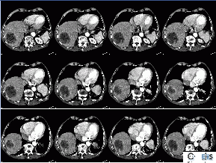 | 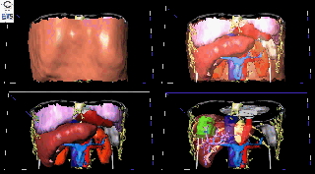
Result of the anatomical structure delineation from a spiral CT-Scan: skin, bones, lungs, kidneys, heart, spleen, gall blader, liver, hepatic veins and hepatic tumors.
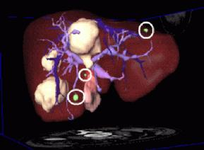 | 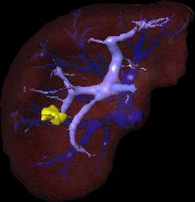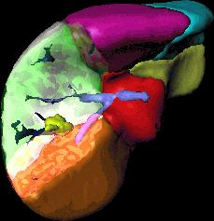
a | b
Results of clinical validation: (a) the three small green lesions were missed by the radiologist, two were cysts but one was a tumor and modified the surgical planning. (b) lesion is localised easily between segments V and VI. The precise delineation of portal vein and hepatic vein allowed to reduce resection.
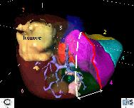 | 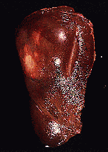
a | b
Results of clinical validation: (a) 3D-model of the anatomical segments of a patient.
The white dotted line is the theorical definition of the cutting-plane separating right and left liver.
The red line is the computerized one validated correct during surgery.

